SCC ICT
Guidance on Creating a New Pastoral Structure
Step by step user guide for schools
Author : David Sheppard
Authorised by : Lizzie Winter
Version : 2.0
Date : 30/05/2023

Table of contents
Contents
1. Introduction 3
1.1. Purpose 3
1.2. Assumptions and Constraints 3
2. Creating a New Pastoral Structure 3
2.1. Opening the Next Academic Year Structure 3
2.2. Adding a new year group 4
2.3. Adding a Registration Group 7
3. Renaming an object (ie Year Group, Registration Group, etc) 8
4. Changing to Vertical Structure 9
5. Changing to Horizontal Structure 10
6. Moving Members to a Year/Registration Group. 11
7. Useful Links: 12

Introduction

Purpose
Procedure documentation for checking and updating the pastoral structure in Sims .Net version 7.210 for the new academic year.

Assumptions and Constraints
This guide needs to be used in conjunction with your ESS Detailed End of Year Procedure. This can be located from the Sims 7 Documentation Centre.
These instructions are primary school focused but can be used as guidance for secondary schools.
Assumption is that the staff changes have been made in sims. The new academic year has been created.

Creating a New Pastoral Structure
Note: Remember to save the changes you undertake in the Pastoral Structure as these will be lost if you close the window or Sims without saving first.

Opening the Next Academic Year Structure
Go to Focus | School | Pastoral Structure | Next Academic Year Structure
Note: If you have not setup the new academic year it will force you to create one when to select ‘Next Academic Year Structure’.
The new pastoral structure for the next academic year is copied from the current academic year. The effective date will automatically default to the first day of the new academic year, click GO to display. To expand a tree to see more details, click on the + symbol to the left of a group to expand it. Clicking on the – symbol collapses the branch to reduce clutter.
Note: Never rename, this renames the present pastoral structure objects, (ie Year Group, Registration Group, etc), along with the new pastoral structure as the objects are still linked.
There are two group types of structure that can be used in this pastoral area:
Horizontal, commonly used when classes are separated:
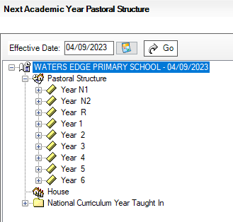
Vertical, commonly used when classes are shared. For example, year R and year 1 have low class numbers so it has been decided that they will be taught in the same classroom. This part has been changed from horizontal to Vertical structure:
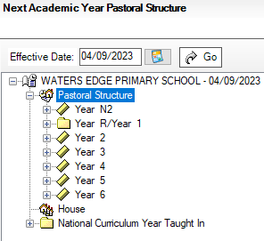
This will make it easier to take registration for that classroom.

Adding a new year group
Ensure that the ‘National Curriculum Year Taught In’ covers this year group you would like to add. Remember, you can expand out the branch by clicking on the + symbol.
When you create a new year group it will need to be associated with the appropriate ‘National Curriculum Year Taught In’.
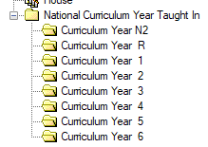
Here we are trying to add N1 year group, however it does not exist. Right click on ‘National Curriculum Year Taught In’ and select the ‘Setup Curriculum Years…’ option.
This will allow us the ability to select the option ‘Curriculum Year N1’.
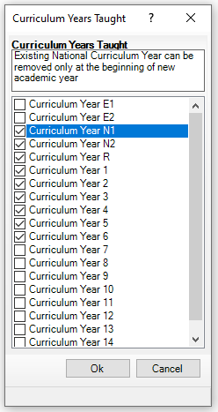
Now that the Curriculum year has been selected, we can create a new year group. First check to see if you have an old year group that you wish to use:
Right click on point ‘Pastoral Structure’ and then select ‘Reuse old Year Group’.
This will display any previously deleted year groups.
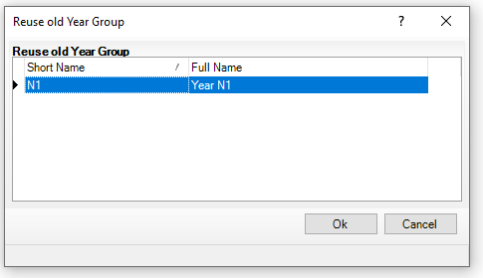
Note: When you delete a year in the Pastoral Structure it is not really deleted, it is only removed from the structure. The object still exists that can be returned in this manner.
If no structure exists, then right click on the ‘Pastoral Structure' and select ‘New Year Group’.
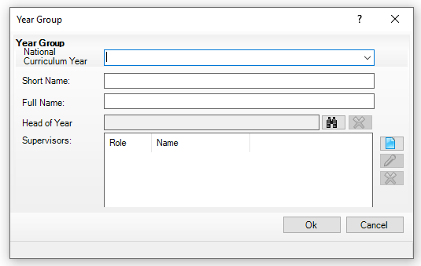
If you have reused a year group, then right click on the year group and select properties to add current details to this year group.
Whether you have created a new year group or reused an old one you would have to populate with the require details. Head of year can be searched for using the ‘binoculars’ icon to the right of the field box. Supervisors can be populated using the note pad symbol to the right of the appropriate box. For the supervisors, you would have to select a role for them.
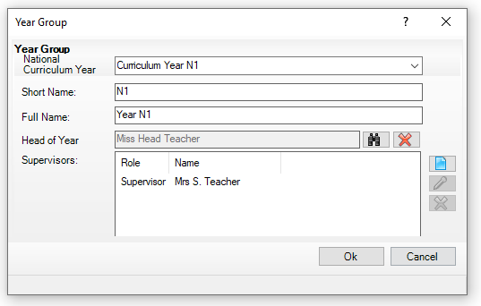
Each year group must have a registration group assigned to it.

Adding a Registration Group
Check if you can reuse a registration group first, which can be achieved in a similar manner to finding an old year group. Right click on ‘Registration Group’ and then select ’Reuse old Registration Group.
In this instance, their used to be two registration groups for N1to add.
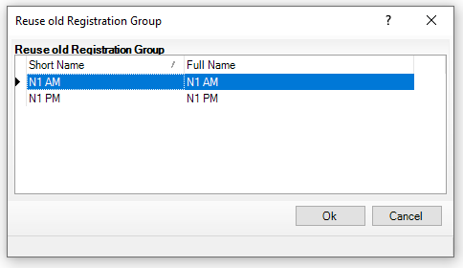
If you cannot reuse a registration group, then select ‘New Registration Group…’ instead. Either way, you would have to populate the registration group with a ‘Registration Tutor’ and ‘Supervisors’. Supervisors would require a role; both can be searched for the same way that the year group could be searched.
For the registration tutor, click on the ‘binoculars’ icon to the right of the registration tutor field. Then search by name.
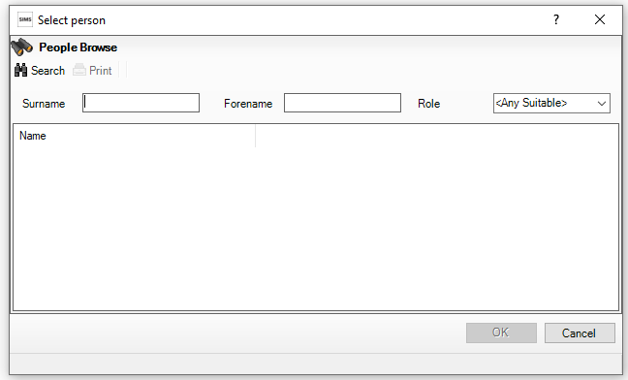
Double clicking on a name or selecting the name and clicking ok will populate the registration tutor role.
For supervisor role, select the page symbol to the field then select the role type, click on the magnifying glass to the right of the person field and you can search by name. Again, double clicking on a name or selecting the name and clicking ok will populate the supervisor role. Both the registration tutor and the supervisor can take registration for this group.

Now associate this registration group with a year group by right clicking on the newly formed registration group and selecting the ‘Associate with New Year Group’ option.
Then select the appropriate year group, this information will be carried to the promotion step when it has been saved.
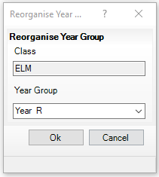

Renaming an object (ie Year Group, Registration Group, etc)
Do not do it!
If you would like to have new name for a year group, registration etc, create a new one and populate this as you would like to.
Each registration group or year group etc, are an object that is linked to its past instance. So, if you change the name of a re-used registration group or one passed through from the current pastoral structure. You will change the name of that object in every academic year it was used in.

Changing to Vertical Structure
As mentioned in section 2, vertical structure is normally used when two or more year groups are taught in the same classroom. This can occur when a pupil population diminishes enough so that both groups can be mixed and taught by one tutor.
To achieve this, right click on ‘Pastoral Structure’ and then select ‘Organise Year Group Vertically’.
Select the two year groups that you would like to arrange together then select ‘OK’.
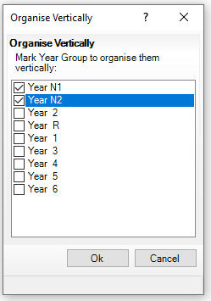
This will arrange them on one line.
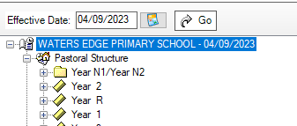
This will automatically put the registration classes for both year groups in the ‘Registration Group’ for this new structure. All other information will be retained within each object as it was prior to the new arrangement, (ie, registration tutor will remain for each registration group).
If the school requires a change to details for a year group/registration group. First locate the object then right click on that object. Select properties, from the properties box you can edit the details there as desired.
Note: Again, never rename an object as this renames the current and past years this object existed in.

Changing to Horizontal Structure
As mentioned in section 2, this is used normally when that year group is not mixed with another year group. Should a population of a year group grow and require its own tutor, you should move to a Horizontal Structure.
To achieve this, right click on year group you wish to separate and then select ‘Organise Year Group Horizontally’.
This will allow you to “unmix” the registration groups to the correct year group.
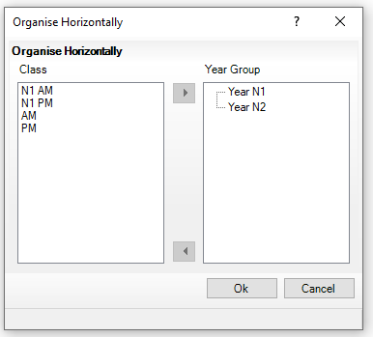
Select the class, which is the registration group, then select the year group, now you will be able to select the triangle indicating right.
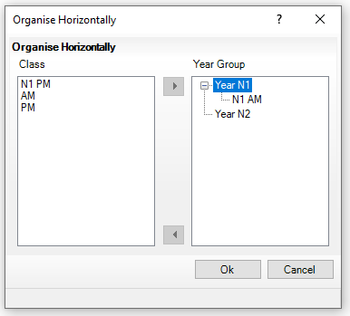
Repeat this process until all the classes have been moved to the appropriate year group. If you make a mistake, then just select the class and follow by selecting the triangle pointing back. Once you are happy then click on ‘OK’ to close the box.
If the school requires a change to details for a year group/registration group, first locate the object then right click on that object. Select properties, from the properties box so you can edit the details there as desired.
Association to the year group is automatically undertaken by sims in this process.
Note: Again, never rename an object as this renames the current and past years this object existed in.

Moving Members to a Year/Registration Group.
Note: Promotion is not undertaken in the Pastoral Structure and is not a substitution process.
Note: You cannot view the members of a group if you have not saved your changes in the pastoral structure. You may be unable to see members in the pastoral structure if you revisit this area after promoting your pupils if you have not saved the promotion steps either.
If you have promoted children, you can check the membership of the pastoral structure/year group/registration. This can help spot members that have been missed, especially if there have been last minute changes.
You can check the distribution of the pupil, (members), by right clicking on ‘Pastoral Structure’ then the ‘Members’ option.
You will then be given a grid with ticks for each pupil allotting them to a year group and displays 100% of enrolled pupils for the next academic year. So, if you have not made you leavers as leavers, they will appear but unassociated with either a year or registration group.
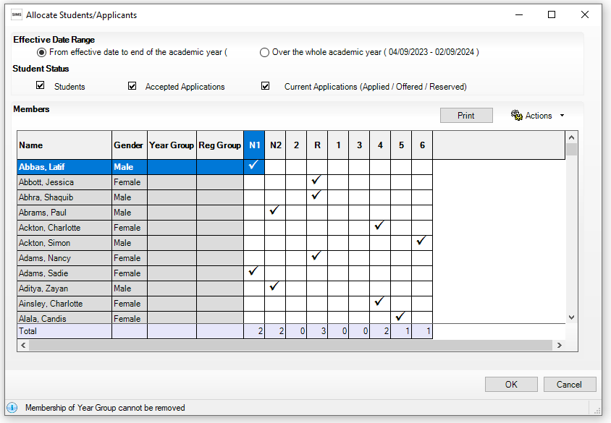

If a pupil lacks a tick, then they are not assigned to a year group. You can assign/re-assign a child by selecting the year group box appropriately. If you right click in the grid, you can select ‘Date of Birth’ this can help identify if you have missed a leaver rather than a promotion, especially in last minute changes.
If you right click on a year group and select ‘Members’ then you will filter the enrolled pupils to just that year group, however, you can then view which registration group they are in.
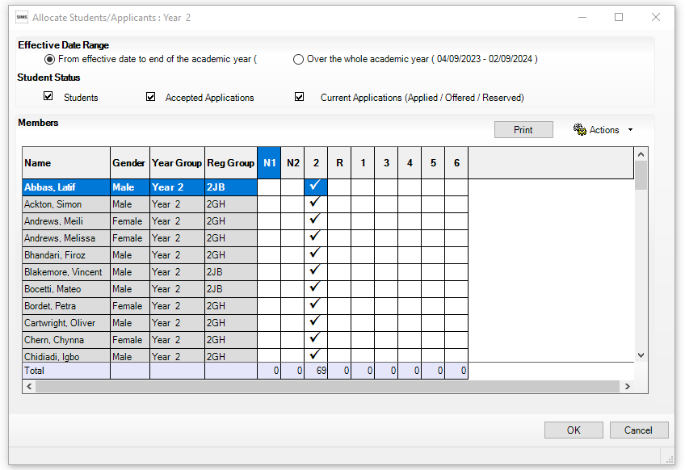
You cannot re-assign them to a different class in this collection but can place them in another year group.
If you right click on the ‘Registration Group’ you will see the grid where you can assign them to a different tutor group.
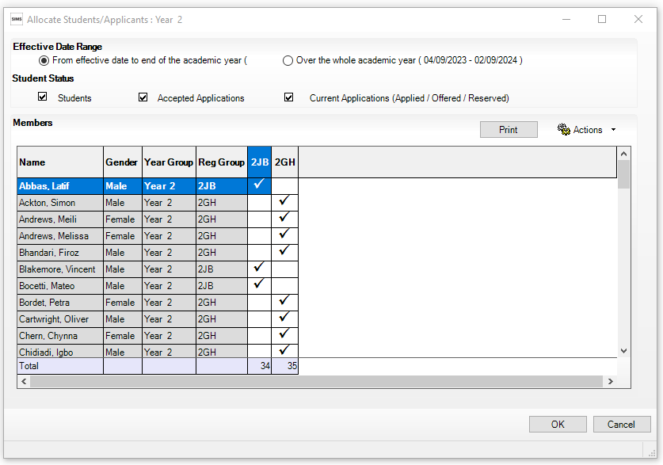

Useful Links:
Sims 7 Documentation Centre

