

|  |  |
| --- | --- |
| **CONTINENCE PROMOTION ASSESSMENT** | |
| Child’s Name: | Date of Birth:  NHS No: |
| Diagnosis: | Medication: |
| Reason for assessment: (routine, review, annual or referral) | Allergies: |
| Assessment completed by: | Date: |

1. Tell me what toileting is like for your child? What’s a typical day for you?

_________________________________________________________________________

_________________________________________________________________________

_________________________________________________________________________

­­­­­­­­­­­­­­­­­­­­­­­­­­­­­­­­_________________________________________________________________________

1. Have you tried toilet training before? If so, what happened? How old was your child?

_________________________________________________________________________

_________________________________________________________________________

_________________________________________________________________________

_________________________________________________________________________

1. What happens about toileting at School?

_________________________________________________________________________

_________________________________________________________________________

_________________________________________________________________________

_________________________________________________________________________

|  |  |  |
| --- | --- | --- |
| **Bladder function – bladder emptied** | Tick | Notes |
| 1 More than once per hour |  |  |
| 2 Between 1-2 hourly |  |
| 3 More than 2 hourly |  |

|  |  |  |
| --- | --- | --- |
| **If night-time wetting occurs** | Tick | Notes |
| 1 Frequently, ie every night |  |  |
| 2 Occasionally ie has odd dry night |  |
| 3 Never |  |

|  |  |  |
| --- | --- | --- |
| **Bladder control** | Tick | Notes |
| 1 Never or rarely passes urine on toilet/potty |  |  |
| 2 Passes urine on toilet sometimes |  |
| 3 Passes urine on toilet every time |  |
| 4 Can initiate a void on request |  |

|  |  |  |
| --- | --- | --- |
| **Sitting on the toilet** | Tick | Notes |
| 1 Afraid or refuses to sit |  |  |
| 2 Sits with distraction or encouragement |  |
| 3 Sits briefly with or without toilet adaptation |  |
| 4 Sits long enough to complete voiding or bowel action |  |

|  |  |  |
| --- | --- | --- |
| **Going to the toilet** | Tick | Notes |
| 1 Gives no indication of need to go to the toilet |  |  |
| 2 Gives some indication of need to go to the toilet |  |
| 3 Sometimes goes to or indicates need for toilet of own accord |  |

|  |  |  |
| --- | --- | --- |
| **Handling clothes at toilet** | Tick | Notes |
| 1 Cannot handle clothes at all |  |  |
| 2 Attempts or helps to pull pants down |  |
| 3 Pulls pants down by self (if physically able) |  |
| 4 Pulls clothes up and down without help |  |

|  |  |  |
| --- | --- | --- |
| **Behaviour problem, that interferes with toileting process eg screams when toileted, faecal smears** | Tick | Notes |
| 1 Occurs frequently |  |  |
| 2 Occurs occasionally, ie less than once a day |  |
| 3 Never occurs |  |

|  |  |  |
| --- | --- | --- |
| **Wears pads, disposable pants or similar** | Tick | Notes |
| 1 Yes |  |  |
| 2 No |  |

|  |  |  |
| --- | --- | --- |
| **Toilet** | Tick | Notes |
| 1 Requires toileting aids or adaptations |  |  |
| 2 Uses normal toilet/potty |  |

|  |  |  |
| --- | --- | --- |
| **Response to basic commands, eg ‘come here’** | Tick | Notes |
| 1 Never responds to commands |  |  |
| 2 Occasionally responds |  |
| 3 Always responds |  |

|  |  |  |
| --- | --- | --- |
| **Diet** | Tick | Notes |
| 1 Refuses/unable to eat any fruit/veg |  |  |
| 2 Will occasionally eat fruit/veg each day |  |
| 3 Eats adequate amount |  |

Suggested daily intake of drinks for children& young people (Bladder & Bowel UK/ ERIC produced by Ferring Pharmaceuticals 2020)

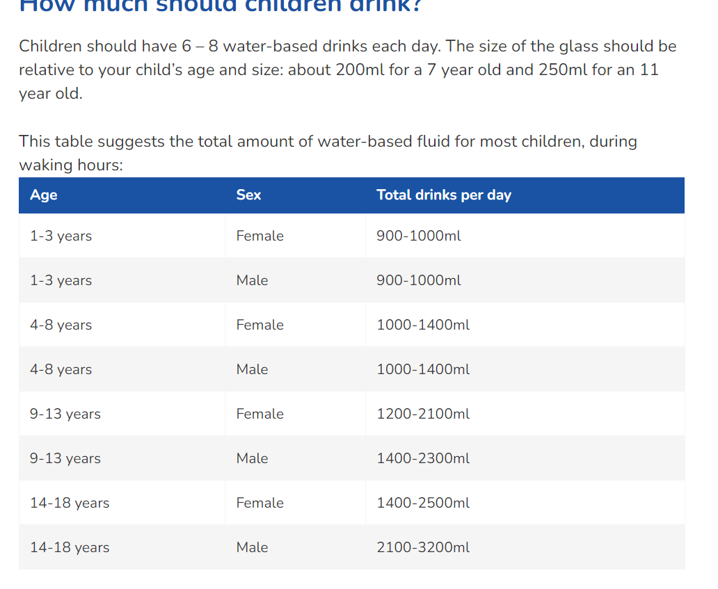

Suggested intake of water-based drinks per 24 hours according to age and sex (NICE2010)

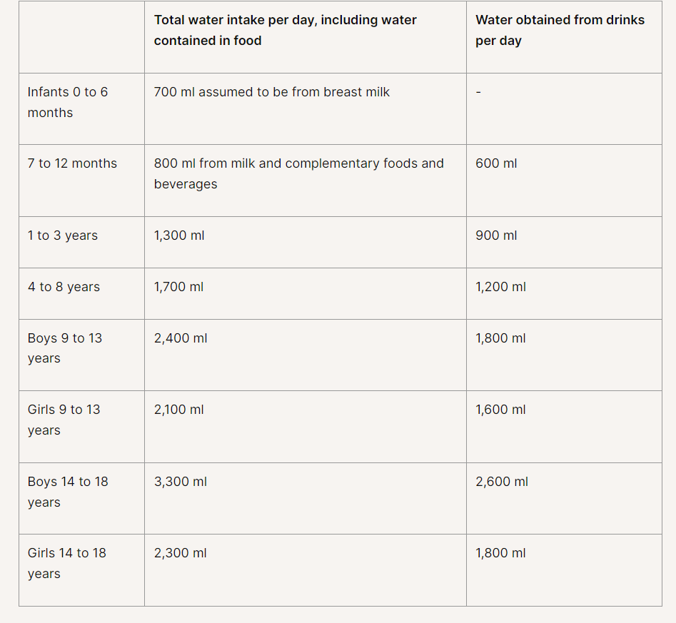

Please note: Children and Young People should drink more on hot days or when they are physically active

|  |  |  |
| --- | --- | --- |
| **Fluid intake** | Tick | Notes |
| 1 Drinks little (sips, small drinks or less than 3 good drinks) |  |  |
| 2 Drinks moderate amount (4-5 small to medium drinks) |  |
| 3 Drinks good amount (6+ good size) drinks |  |

|  |  |  |
| --- | --- | --- |
| **Bowel function** | Tick | Notes |
| 1 Has more than three bowel actions per day |  |  |
| 2 Does not always have normally formed bowel movements ie is subject to constipation or diarrhoea |  |  |
| 3 Has regular normally formed bowel movements |  |  |

|  |  |  |
| --- | --- | --- |
| **Night-time bowel movements** | Tick | Notes |
| 1 Occur frequently ie every night |  |  |
| 2 Occur occasionally ie has some clean nights |  |
| 3 Never occurs |  |

|  |  |  |
| --- | --- | --- |
| **Bowel control** | Tick | Notes |
| 1 Never or rarely opens bowels on toilet/potty |  |  |
| 2 Opens bowels on toilet sometimes |  |
| 3 Opens bowels on toilet every time |  |

|  |  |  |
| --- | --- | --- |
| **Constipation** | Yes | No |
| Does the child or young person have a bowel movement (poo) fewer  than three times a week (stool type 3 or 4)? |  |  |
| Image result for bristol stool chart | Which type? | |
| Have you noticed any soiling (very loose, very smelly stool passed  without sensation) in recent days? |  |  |
| Does the child/young person have poor appetite that improves with  the passage of a large stool? |  |  |
| Does the child or young person experience abdominal pain that comes  and goes with the passage of stool? |  |  |
|  | Yes | No |
| Is there evidence of retentive posturing typically straight-legged,  tiptoed, back arching posture)? |  |  |
| Does the child or young person experience anal pain? |  |  |
| Has the child or young person had any previous episodes of  constipation or the present symptoms? |  |  |
| Have you noticed any cracks or tears in the anal region? |  |  |
| Does the child or young person bleed when passing stools? |  |  |

More than 2 ‘yes’ above indicates constipation

**SUMMARY**

**ACTION PLAN FOR CONSTIPATION**

|  |  |  |
| --- | --- | --- |
|  | Yes | No |
| Indicates constipation |  |  |
| If ‘yes’ to above |  |  |
| Advise parent/carer to go to GP |  |  |
| Task GP |  |  |

**ACTION PLAN FOR CONTINENCE PROMOTION**

|  |  |  |
| --- | --- | --- |
|  | Yes | No |
| Send a copy of assessment to parent/carer |  |  |
| Consent given to share data with Provider |  |  |
| Copy attached to SystmOne |  |  |
| Equipment/aids suggested |  |  |
| Other interventions e.g. use of visuals, product assessment, next review date | | |
| Parent/carer/young person plan | | |