**Example Sensory Circuit**

*These activities are for examples only and may not be suitable for every child.*

START

FINISH

**Calming Activities**

**Organising Activities**

**Alerting Activities**

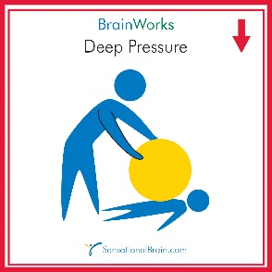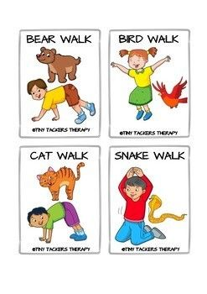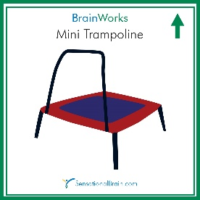

Jumping

Ball squash

Animal walks

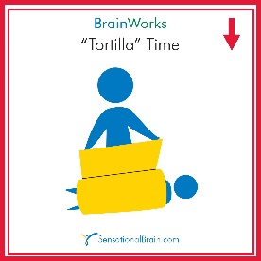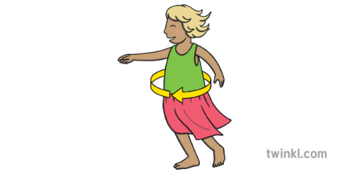

Spinning

Ball roll

Blanket wrap