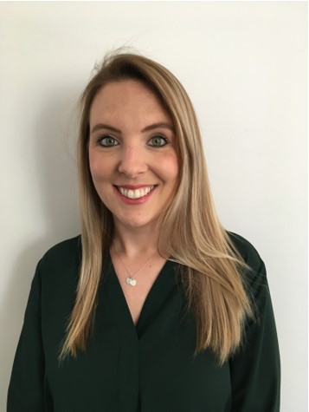 |  |  | What’s important to me…  - Working collaboratively with families and professionals.  - Keeping children at the heart.  - Placing psychology at the forefront.  - Being part of a well-connected team.  - Supporting others to feel seen and heard.  - Values-driven practice.  - Relationships. | Dr Holly Robertson  Deputy Principal Educational Psychologist
How best to support me…

I prefer to communicate with people face-to-face where possible.

I like to see and connect with colleagues in our workspaces.

Pick-me-ups include milky coffee, humour, walking & talking and chocolate.

About me…

As Deputy Principal, I help lead the educational psychology service and strategic initiatives.

I am passionate about applying psychology in creative ways to maximise accessibility and impact for the communities we serve.

I enjoy working systemically; strengthening processes to harness positive outcomes.

My interests include community psychology, team learning, and organisational change.

.

Colleagues have noticed that…

- I value transparency, equity, autonomy, and individualism.
- I am motivated to find strategic solutions to presenting problems.
- I prioritise people and demonstrate a collectivist mindset.
- I can display courage and will not shy away from tricky situations.

