Via Email

Date:25th June 2024

Enquiries to: Jason Crane

Email: lhb@suffolkhighways.org

Dear Sir or Madam,

**INITIAL CONSULTATION FOR THE PROPOSED SAFETY MEASURES AROUND FLATFORD MILL AREA.**

Following concerns raised by the National Trust, regarding vehicle speeds and road safety issues within the Flatford Mill area, and with the support of Suffolk County Council. Suffolk County Council are proposing to implement “No Waiting at any time’ restrictions, pedestrian signage, improved advance directional signage and a two-way section at the entrance of the car park and Flatford. These proposals will guide visitors to the appropriate car parks, reduce vehicles travelling along and blocking Flatford and provide National Trust with the means to provide a specially adapted vehicle to provide a service between the upper car park and Bridge Cottage, for visitors with mobility difficulties.

Please find attached for your perusal, a plan showing the extent of these proposals, more detailed drawings are available via our consultation page at [consultation@suffolkhighways.org](mailto:consultation@suffolkhighways.org) or upon a request at the address below.

I would welcome any comments or concerns that you have relating to the proposal. Any comments that you wish to make can be submitted using the e-mail address at the top of this letter or by letter to Phoenix House, 3 Goddard Road, Ipswich, IP1 5NP. All comments must be received by 19th July 2024.

Yours sincerely

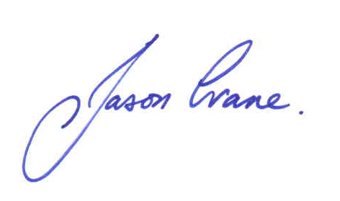

Design Engineer – LHB and Minor works Team

